Java Installation Steps
Step 1: Download Java JDK
Step 2: Install JDK
Step 3: Set Environment Variables
Press Windows + R.
Type: sysdm.cpl
Press Enter to open System Properties
Go to the Advanced tab
Click Environment Variables
Select Path under System Variables
Click on Edit Button
Add New Path C:\Program Files\Java\jdk1.8.0_171\bin
└── OK → OK → OK
Is Java Case Sensitive?

Yes, Java is a case-sensitive language.
This means that uppercase and lowercase letters are treated as different characters.

Explain class key word and class declaration

The class keyword is used to declare or create a class in Java.
class ClassName {
// variables
// methods
}

Class Naming conventions

Java does not enforce naming conventions, but developers follow these standards for readability and maintainability.

Use PascalCase (Upper Camel Case)
Use Meaningful Names
Avoid Special Characters and Spaces
class Student_Details { } // Not recommended
class Student Details { } // Invalid
class Student@123 { } // Invalid

Create a Simple Java File

public class HelloWorld {
public static void main(String[] args) {
System.out.println("Hello, World!");
}
}

Understanding psvm in Java

Breakdown of public static void main(String[] args)
Keyword | Meaning
public | The method can be accessed by the JVM from anywhere.
static | The method belongs to the class, so the JVM can call it without creating an object.
void | The method does not return any value.
main | The predefined method name that the JVM looks for to start execution.
String[] args | An array of command-line arguments passed to the program.

Explain SOP statement

Breaking Down System.out.println()
1. System
System is a predefined class in the java.lang package.

2. out
out is a static object of PrintStream class that represents the standard output stream (console).

3. println()
println() is a method of the PrintStream class used to print data and move the cursor to the next line.

CMD Commands to Compile and Run a Java Program
Assume you have a file named HelloWorld.java.

Compile the Java Program
javac HelloWorld.java

Run the Java Program
java HelloWorld

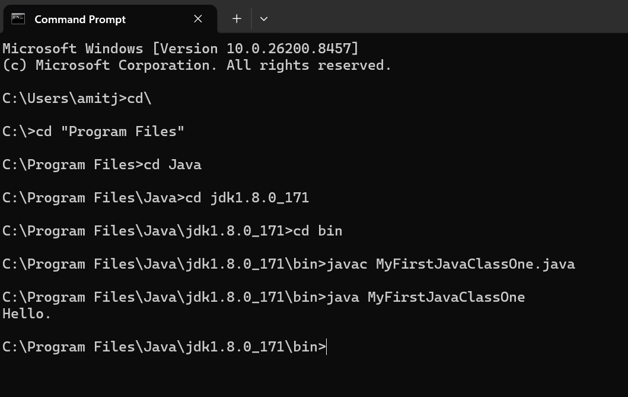

Compile the Java Program

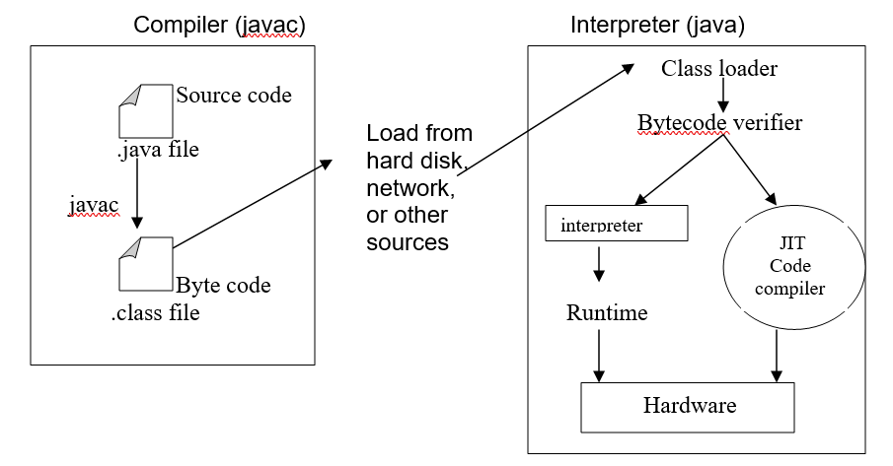

Runtime Execution Flow

JVM Starts
│
▼
Loads HelloWorld Class
│
▼
Finds main() Method
│
▼
Executes Statements Inside main()
│
▼
Program Ends

How Many Classes Can Be Declared in a Single Java File?

You can declare any number of classes in a single Java file.

However, there are some important rules:

Rule 1: Only One Public Class is Allowed

A Java file can contain only one public class.

✅ Valid:

public class Test {
}

class Student {
}

class Employee {
}

File name:

Test.java

Rule 2: File Name Must Match the Public Class Name

If a class is declared as public, the file name must be the same as the public class name.

public class Test {
}

File name:

Test.java

❌ Invalid:

public class Test {
}

File name:

Demo.java

Compilation Error:

class Test is public, should be declared in a file named Test.java

Rule 3: If No Class is Public

You can declare multiple classes, and the file can have any valid name.

class A {
}
class B {
}
class C {
}

File name can be:

MyFile.java
Interview Answer

A single Java file can contain multiple classes, but only one class can be declared as public. If a public class exists, the file name must match that public class name.

Getting Input in Java

The most common way to take input from the user in Java is by using the Scanner class.
Step 1: Import Scanner
import java.util.Scanner;

Step 2: Create a Scanner Object
Scanner sc = new Scanner(System.in);

Example: Taking an Integer Input

import java.util.Scanner;

public class InputDemo {
public static void main(String[] args) {
Scanner sc = new Scanner(System.in);
System.out.print("Enter your age: ");
int age = sc.nextInt();

System.out.println("Age = " + age);
}
}

Explanation
Scanner sc = new Scanner(System.in);
- Scanner → A predefined Java class (java.util.Scanner) used to read input.
- sc → The reference variable (object name). You can choose any valid name, such as input, scanner, or s.
- new → Creates a new object of the Scanner class.
- Scanner(System.in) → Calls the constructor of the Scanner class and connects it to the standard input stream (System.in), which represents the keyboard.

Difference between print() and println() in Java
print() | println()
Prints the output on the console. | Prints the output on the console.
Does not move the cursor to the next line after printing. | Moves the cursor to the next line after printing.
The next output continues on the same line. | The next output starts on a new line.

Java vs JVM

Java is platform-independent because the bytecode generated by the Java compiler is the same regardless of the operating system.
JVM is platform-dependent because you need a different JVM implementation for each operating system/platform.

Regardless of whether the operating system is Windows, Unix/Linux, or macOS, the JVM reads the platform-independent Java bytecode and converts it into machine-specific code that the underlying operating system and CPU can execute.

The flow is:
Java Source Code (.java)
↓ javac
Bytecode (.class) — platform independent
↓ JVM
Machine/Native Code — platform dependent
↓
CPU executes it
For example:

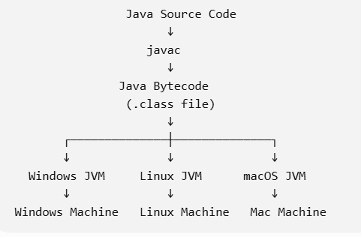

Java bytecode is platform-independent. The JVM on each operating system interprets that common bytecode into machine-specific native instructions.

